**Results and Observations**

**Introduction**

In today's fast world, making things easy to do and getting what we need quickly are very important. This survey is about finding out if people think it's necessary to have an app for getting services done at home.

Technology has changed a lot of things, making it easier for us to do things like ordering food or booking a taxi using apps on our phones. But, there's a big question: Do we really need a special app just for getting services done at home? That's what we're trying to figure out with this survey.

**Methodology**

We used google forms to conduct out the questionnaire, after some discussions amongst the team members we decided that the perfect number of questions would be 10 as it balances out the time needed to complete the form with the essential questions.

**Results**

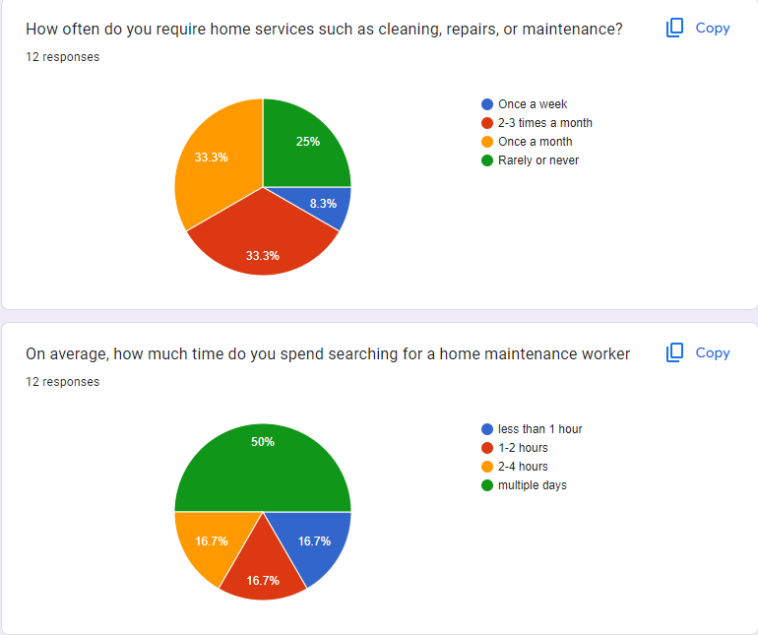

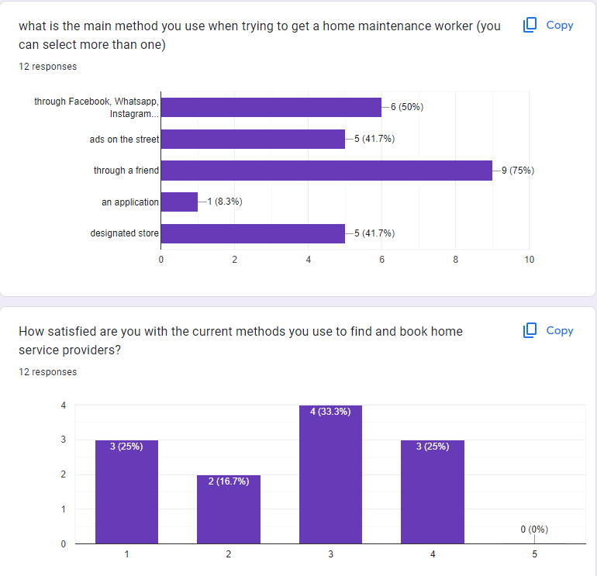

**Key Findings**

* The amount of which people require a home service provider is higher than expected.
* Most users choose the traditional methods when trying to find a home service worker
* Half of the people Who took the survey spend more than one day searching for an appropriate worker
* On average people tend to be neutral with the methods they use to find a worker
* Every single person has given a “Yes” to the idea of having an application which provides home service and almost all of them want it to be on a singular platform which includes the majority of services needed
* As most of our takers are casual users of technology the answers they provided in reference to the importance of security aligned with it, (mixed)
* There was a clear result in regard to how much they valued other reviews when deciding, (Highly)

**Observations**

The results of the questionnaire reveal several noteworthy trends regarding the demand for home service providers and user preferences in accessing such services. Firstly, it is

apparent that there is a higher-than-anticipated demand for home service providers among respondents. Despite this demand, a significant proportion of users continue to rely on traditional methods when seeking out home service workers, with approximately half of the survey participants spending more than a day searching for a suitable worker.

Interestingly, while users exhibit a neutral stance towards the methods they currently employ to find a worker, there is unanimous agreement among respondents regarding the desirability of having a dedicated application for accessing home services. Moreover, the overwhelming majority express a preference for this application to encompass a wide range of services on a singular platform, indicating a strong appetite for convenience and efficiency in service provision.

**Conclusion**

The survey has shown interesting results that ensured us that we are on the right path with our project and highlighted some unexpected answers that will guide us to a better understanding of the needed requirements and what functions to make a priority in our application in the design phase.

**References**

https://docs.google.com/forms/d/e/1FAIpQLSe2D3NjRP5xM0zLN_qSmDAzjYhbMUHQTwqI8H1WD_xpKc5V1A/viewform?usp=sf_link